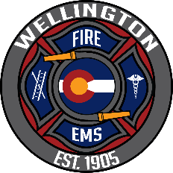 |  | Monthly Service Activity |  |  |  |  |  |  | 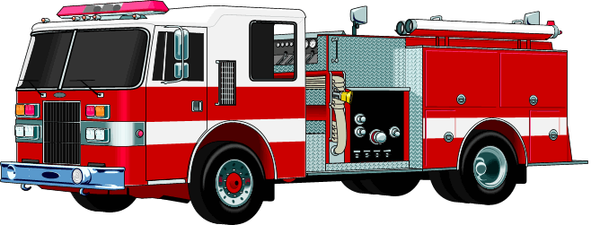
Month | August 2024
TOTAL INCIDENT ACTIVITY: 104  Fire and Related Services: 32  Overlapping (August) 17 (16.35%)  Overlapping (YTD) 167 (20.77%) |  |  |  | YTD: 806  YTD: 282 |  | EMS Responses: 72 |  |  |  |  |  | YTD: 524
GREEN = Increase from prev. month
RED = Decrease “ “ “
Incidents of Interest:

08/04/2024 1118 hrs Wire Down Grass Fire, I-25 E16 responded for reported for a grass fire caused by a downed live wire. Crews contained 2 areas of fire away from the downed lines until power was cut by the utility. Crews were then able to fully extinguish and overhaul the area.

08/10/2024 0835 hrs I-25 SB E16 responded to a report of a car fire on the Interstate. Arrived to find a fully involved Subaru Outback. Crews extinguished and overhauled vehicle. Scened turned over to CHP.

08/22/24 2040 hrs. Motorcycle vs. Cow CR 19 and CR70 E17 responded to a motorcycle accident. Arrived to find an injured cow and the MC rider down a 15’ ditch. Crews assisted in removing pt. from the ditch and packaging for transport by UCHealth. A 2nd MC rider was also transported. Cow was euthanized by veterinarian.

08/23/2024 0509 hrs. MVA w/ Injuries W. CR68 E17 and PFA E6 responded for a rollover MVA. E17 arrived to find a heavily damaged vehicle with a lone occupant partially ejected. PFA E6 called for manpower as E16 was tied up on another call. Crews stabilized the vehicle and forcibly removed 2 doors to extricate the pt. and package for transport by UCHealth.

08/37/2024 1338 hrs. Tractor Trailer Accident I-25 NB MM 290 E16 and E17 arrived to find a Tractor Trailer hauling frozen food on its side in the right hand lane of I-25 NB. Crews extricated the driver by removing the windshield. Driver transported by UCHealth for precautions. A small diesel leak was contained.

